MINIBLUE® pump available with: 9
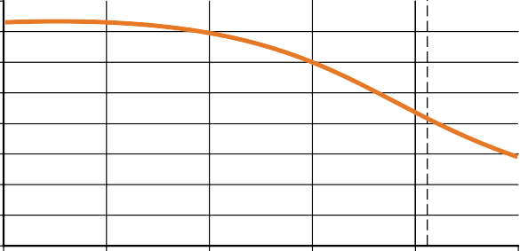

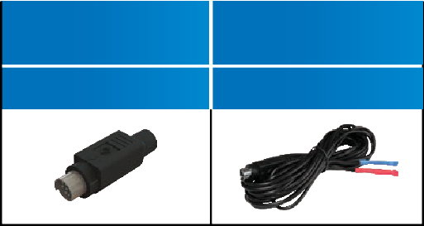
8
CR PLUG
X87-500
RTeEsMerPvEoRirAsTeUnsRoEr
SENSOR
X87-504
7
FLOW RATE L/HR
6
5
4
3
2

0

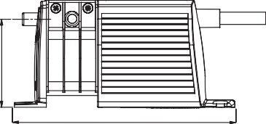
DIMENSIONS (MM)
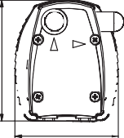
138
All of the BLUEDIAMOND® pumps have the ability to run dry without burning out. Enabling them to remove
58


2 4 6
HEAD (M)

8 10

RUN DRY


WHISPER QUIET
any liquids, preventing organic growth inside the tubing.

Quiet in all stages of operation and not only when set to quiet mode or relying on a soft start setting.
67
55

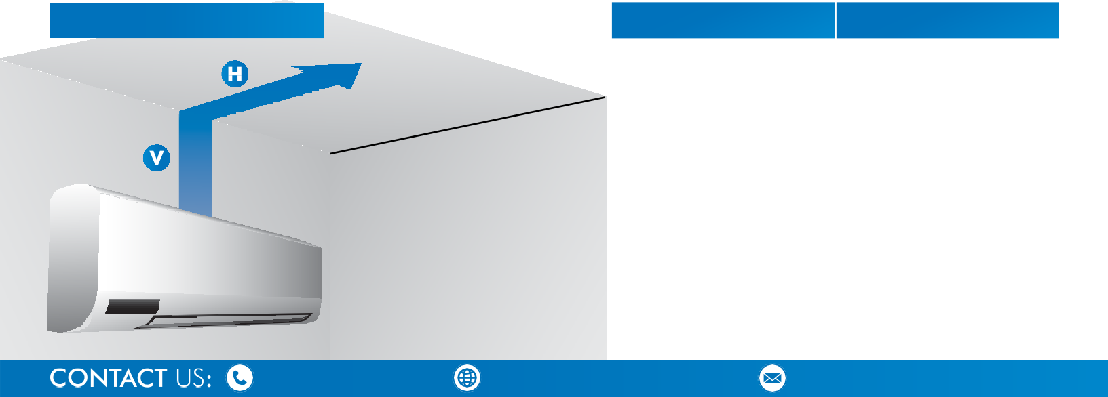
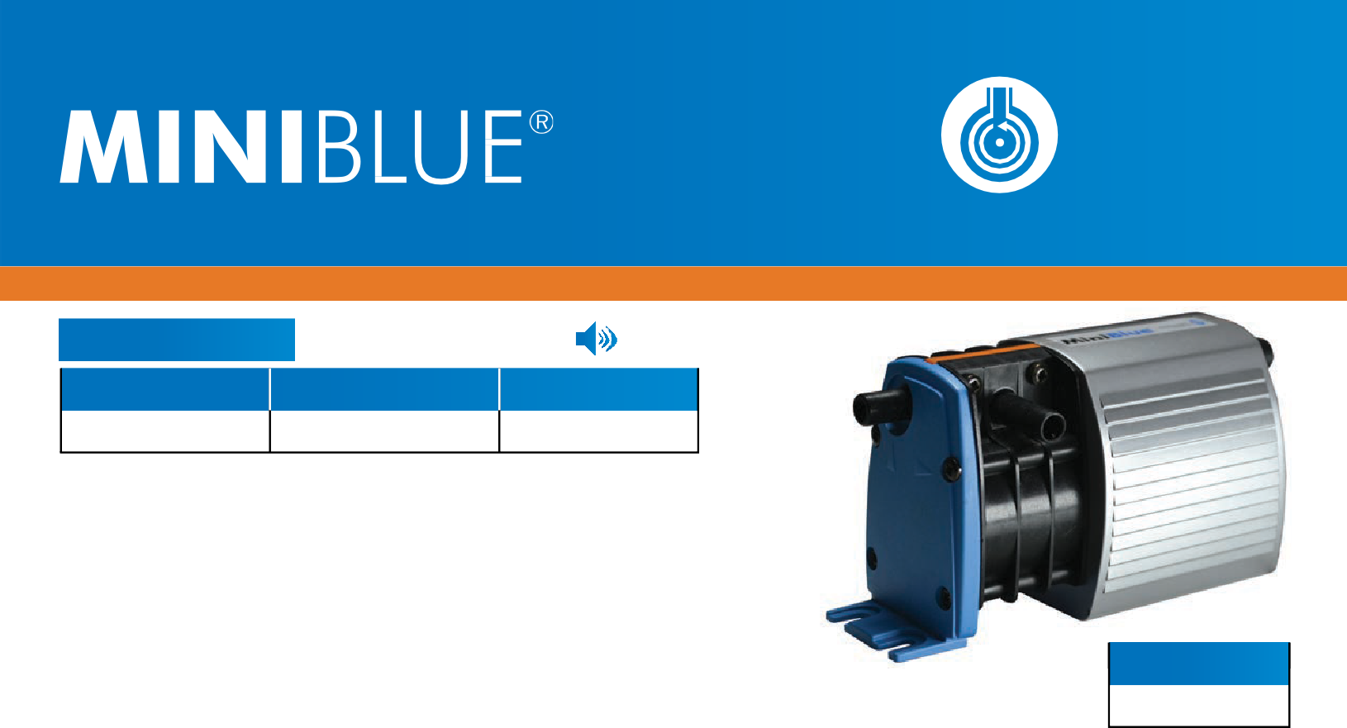


DISCHARGE PIPE RUN
V (VERTICAL)
H (HORIZONTAL)
*8 KW MAX
+44 (0)1932 355 277
TheMINIBLUE® canbemountedinany orientation up to 8m away from the A.C unit.
X
X
ROTARY DIAPHRAGM
3WARRANTY
PERFORMANCE
21 dba
Running either wet or dry, the MINIBLUE® is whisper quiet whilst reliably removing condensate and debris. Inherently reliable whilst self priming it gives peristaltic performance at the price of a piston pump. The MINIBLUE® is small enough to quickly fit, or retro fit, into any existing installation, saving both time and money.

SENSING OPTION
PERFORMANCE
MAX LIFT
5 METRES
MAX HEAD
8 METRES
MAX FLOW
8 L/ HOUR
UNIT
3.5-8 KW
YEAR

8 M | 0 M
7 M | 3 M
6 M | 6 M
5 M | 9 M
4 M | 12 M
3 M | 15 M
2 M | 18 M
1 M | 21 M

